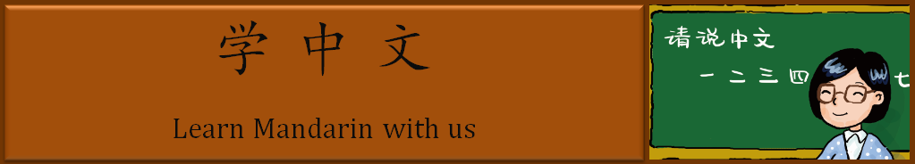

Mandarin 7 Weekly News
Chinese New Year Celebrations

Nihao! Happy Chinese New Year! It is the year of the Monkey. Chinese New Year Started at February 8th and lasted two weeks. Do you remember what traditional decorations are used for Chinese New year? Yes, paper cuttings, red lanterns, kumquat trees, red envelopes, couplets and ink paintings. This year, we did a paper cutting of a monkey in class, and we made dumplings during a Mandarin club meeting. We learned about Chinese culture and had a lot of fun!

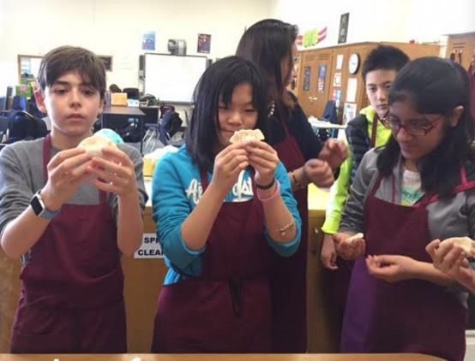
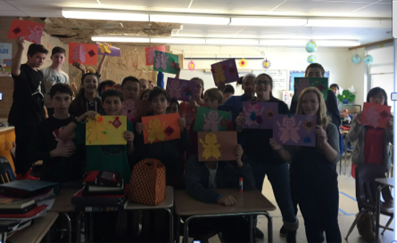

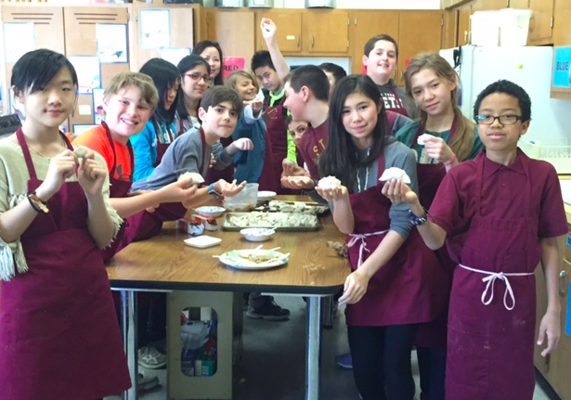
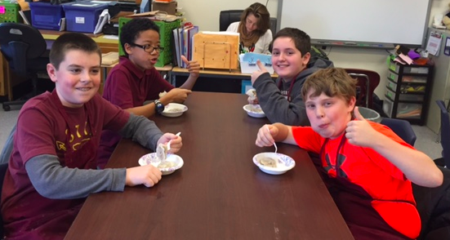

This week we did a schoolbag project to practice the knowledge of lesson 9. Students made their own schoolbags, wrote descriptions and interviewed each other by using the language learned in this lesson. We ended lesson 9 with the project, and we will have a lesson 9 quiz on Monday 2/29. Please click here to find the worksheet of quiz format and review checklist. Moreover, we started an exciting lesson---food through an interesting way (storytelling). We finished first five slides of the story, and we are looking forward to knowing more about the story. In this newsletter, you will see the texts of the story and click to listen to the story. You will also find the vocabulary list of the story. Please have your child study for the coming quiz and enjoy listening and reading the story. Lastly, you will see some activity pictures in Mandarin class.

Please feel free to send me an email if you have any question.
Ms. Wang (wangj@northshoreschools.org)

Story(妈妈，我饿了)

mā mā wǒ è le
哈七： 妈妈，我饿了！！！

hā qī nǐ xiǎng chī shēn me
王老师：哈七，你 想 吃 什 么？

wǒ xiǎng chī hàn bǎo bao hé shǔ tiáo
哈七： 我 想 吃 汉 堡 包 和 薯条。

hàn bǎo bao hé shǔ tiáo bù jiàn kāng, nǐ xiǎng bù xiǎng chī píng guǒ hé xiāng jiāo
王老师: 汉 堡 包 和 薯 条 不 健 康，你 想 不 想 吃 苹 果 和 香 蕉？

wǒ bù xǐ huān chī píng guǒ hé xiāng jiāo, wǒ xǐ huān chī sān míng zhì hé bīng qí
哈七： 我 不 喜 欢 吃 苹 果 和 香 蕉，我喜 欢 吃 三 明 治和 冰 淇
lín. hā qì bù gāo xìng
淋。哈七不 高 兴。

Vocabulary list for the story

Please click here and listen to the pronunciation.

英文 | 中文 | Pinyin
Hungry | 饿 | è
Laugh | 哈 | hā
To want/miss | 想 | xiǎng
To eat | 吃 | chī
One hamburger | 汉堡包 | hàn bǎo bao
French fries | 薯条 | shǔ tiáo
Healthy | 健康 | jiàn kāng
Apples | 苹果 | píng guǒ
Bananas | 香蕉 | xiāng jiāo
To like | 喜欢 | xǐ huān
Sandwiches | 三明治 | sān míng zhì
Ice cream | 冰淇淋 | bīng qí lín

Pictures in Mandarin classroom

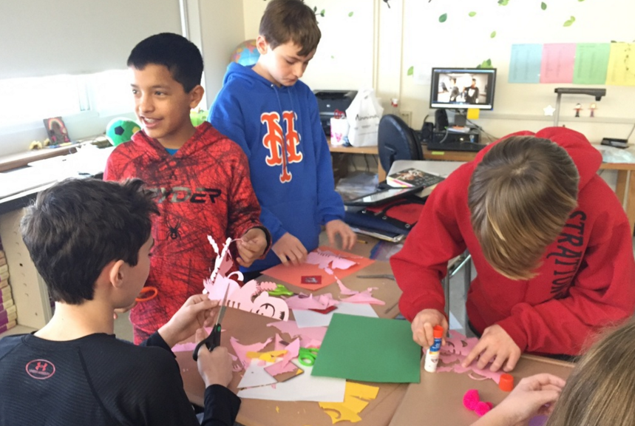
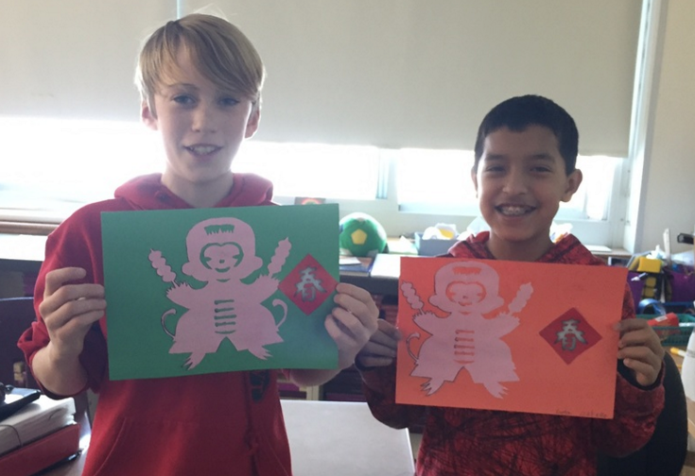

We play Tic Tac Toe in Mandarin.

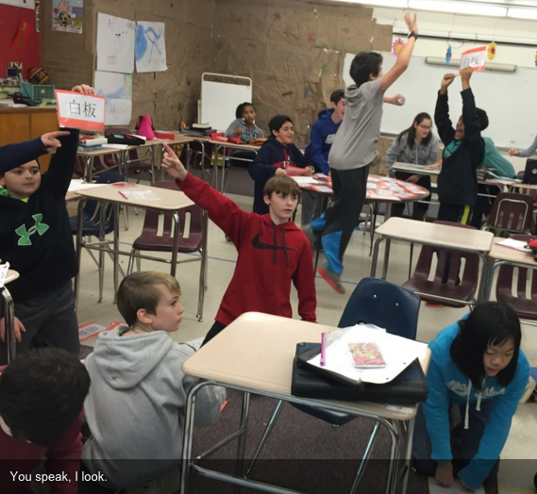
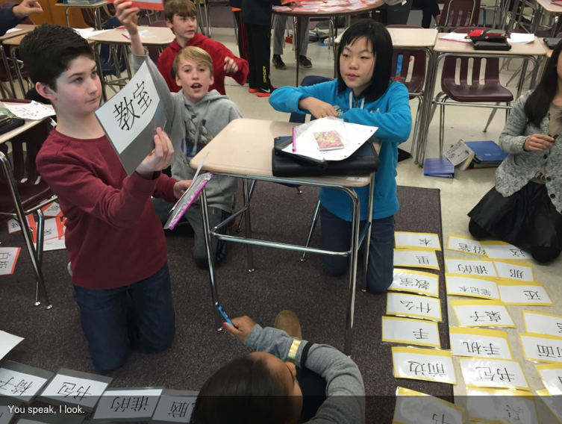
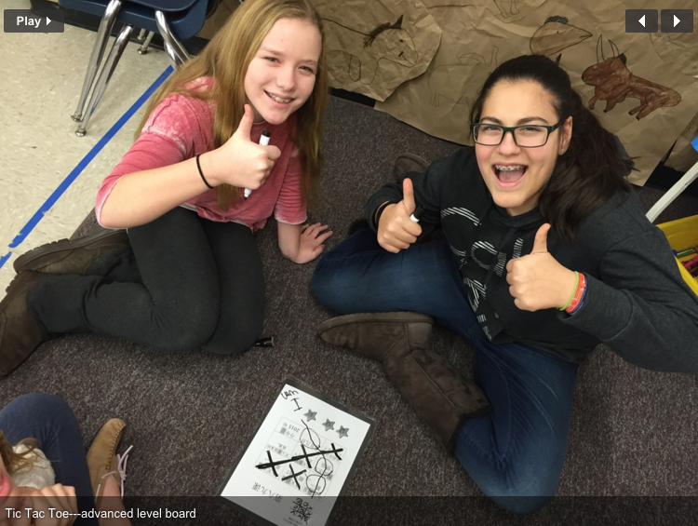
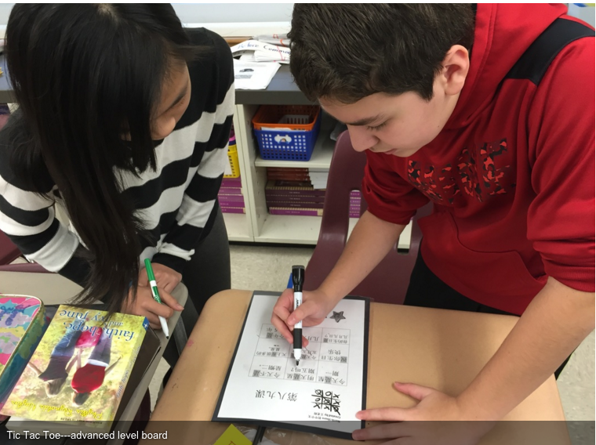
The teacher speaks a phrase. Students look for the characters among a pile of flash cards. The activity assesses listening and character recognition skills.

We play Bingo game in Mandarin. Students practice listening, speaking and character recognition skills.
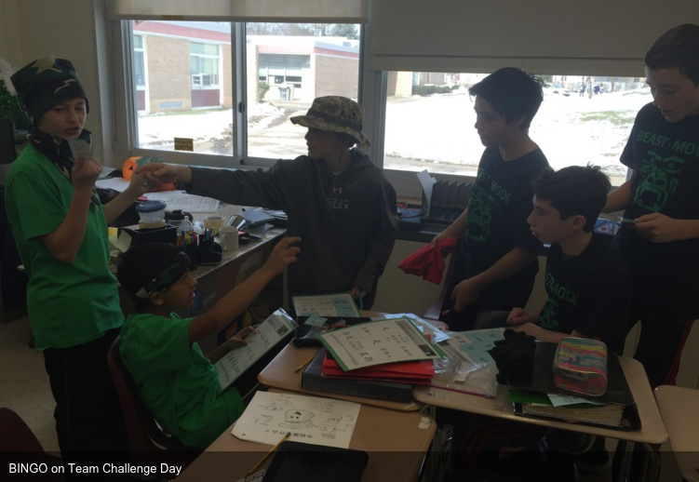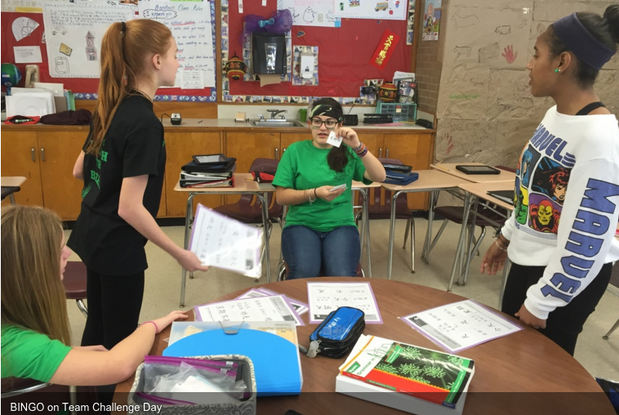

Hedbanz Game in Mandarin classroom!!!
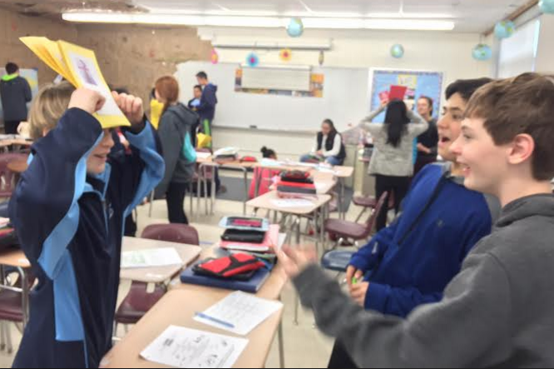
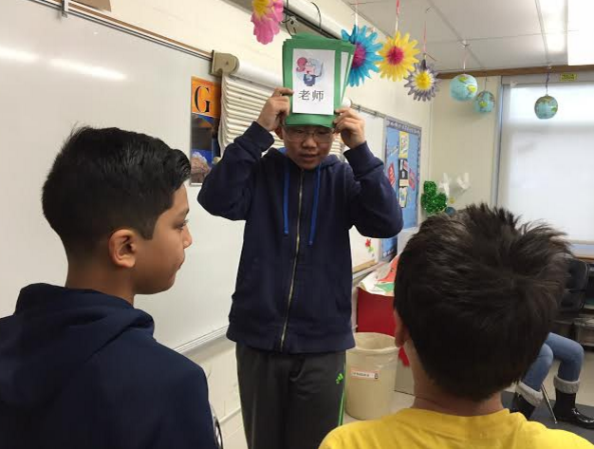

Our Schoolbag Project—Please look at our beautiful schoolbags and Mandarin handwriting.
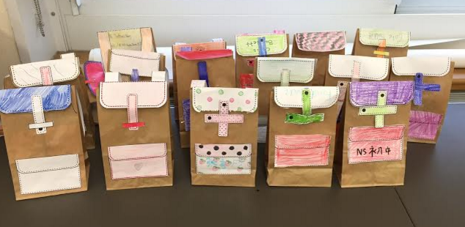

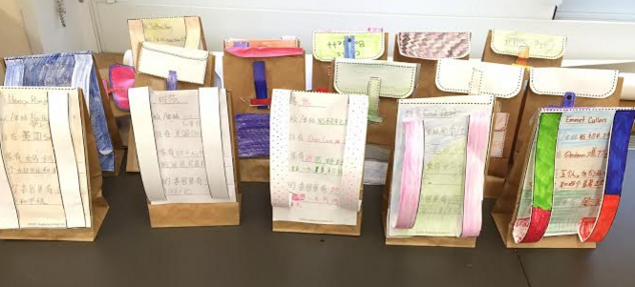
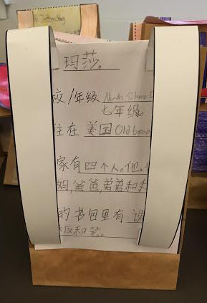
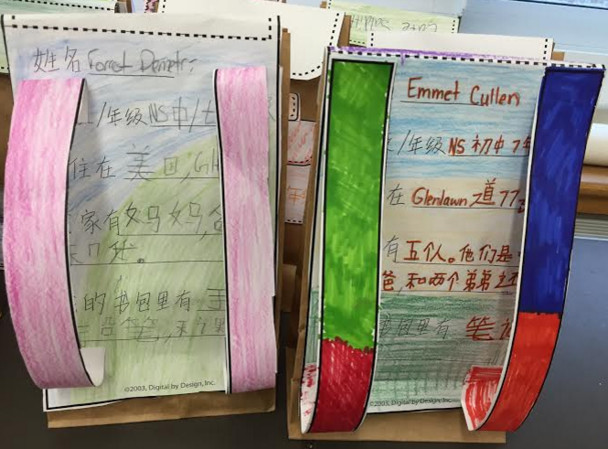

谢谢！！Thank you for reading the newsletter. Please click here to see more pictures in Mandarin classroom.

